Lab 4 ASP.NET

Author: Brian Liang

**Test 1: Technician Service**

Case: Try inputting a valid tech id with open cases.

Results: Returns the open incidents for that technician (one open incident for techID 11)

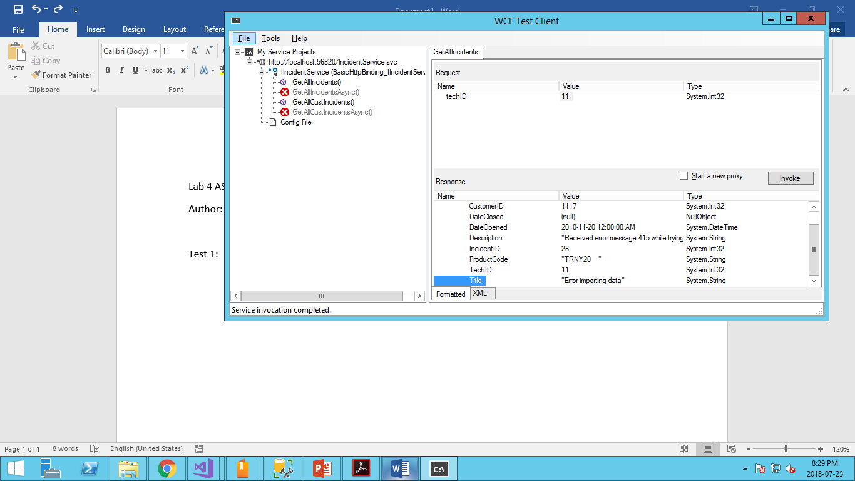

**Test 2: Technician Service**

Case: Try inputting an non existent techID / negative interger

Result: It returned an array of nothing which is correct (we tried techID = -5)

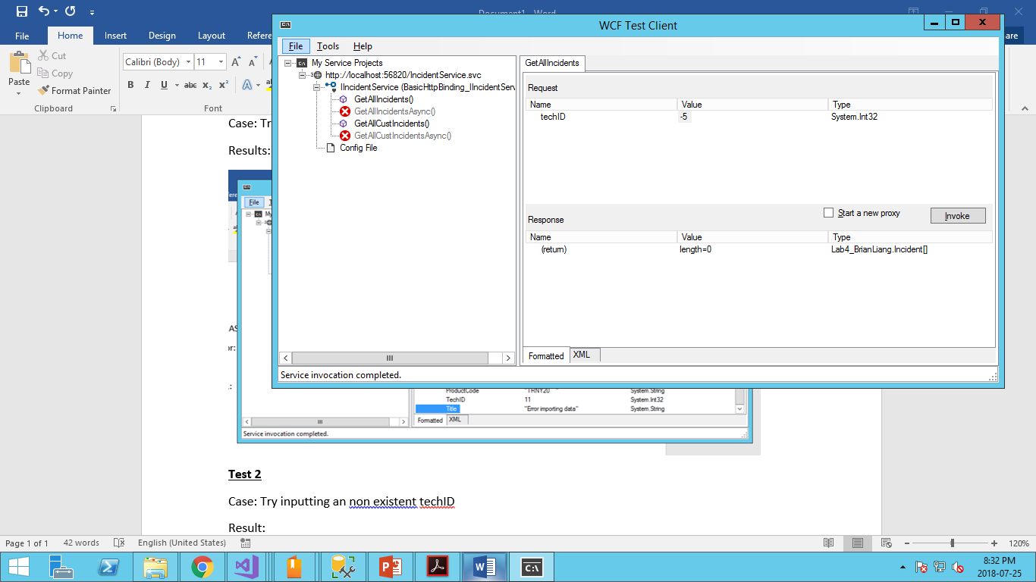

**Test 3: Customer Service**

Test: Test a customer with two incidents

Result: Tested customerID 1116. Initially the program crashed and I learned that it had one item with a techID equal to null (we didn’t need to account for that in lab 3). Therefore I corrected the coding and now am getting the correct answer. The service is returning an array of two and one of them shows TechID as null.

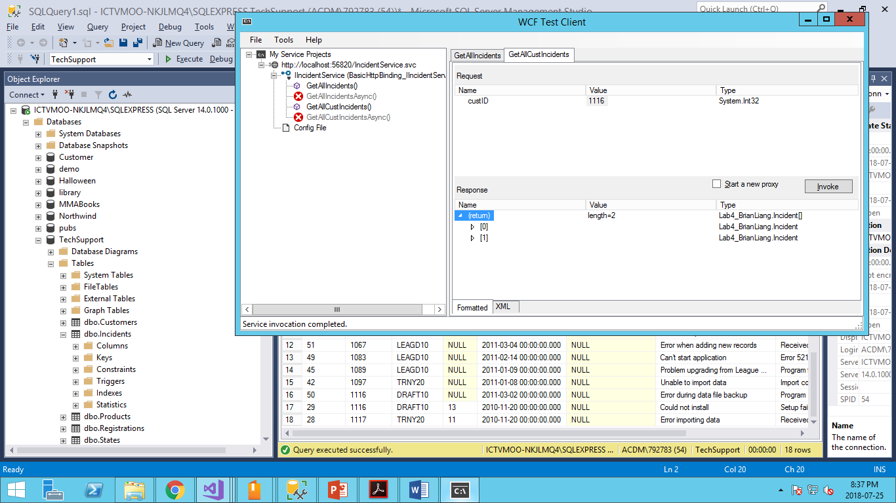 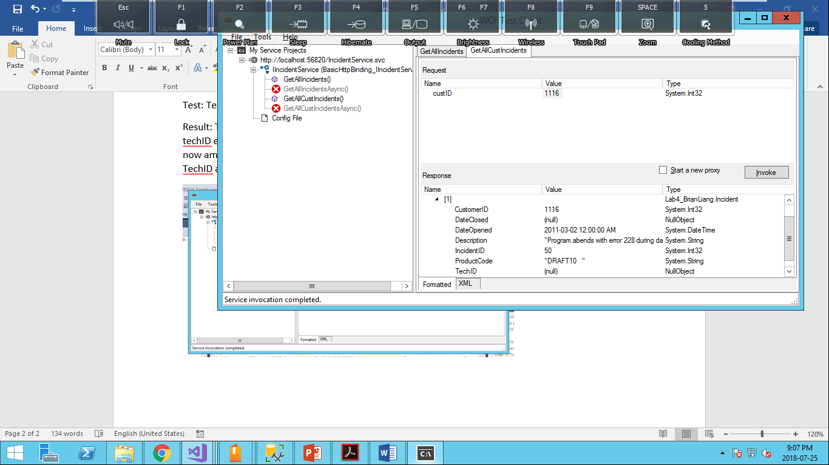

**Test 4: Customer Service**

Test: Test customer ID = 0

Result: Return an array of nothing. Which is correct as there is no customer with ID 0.

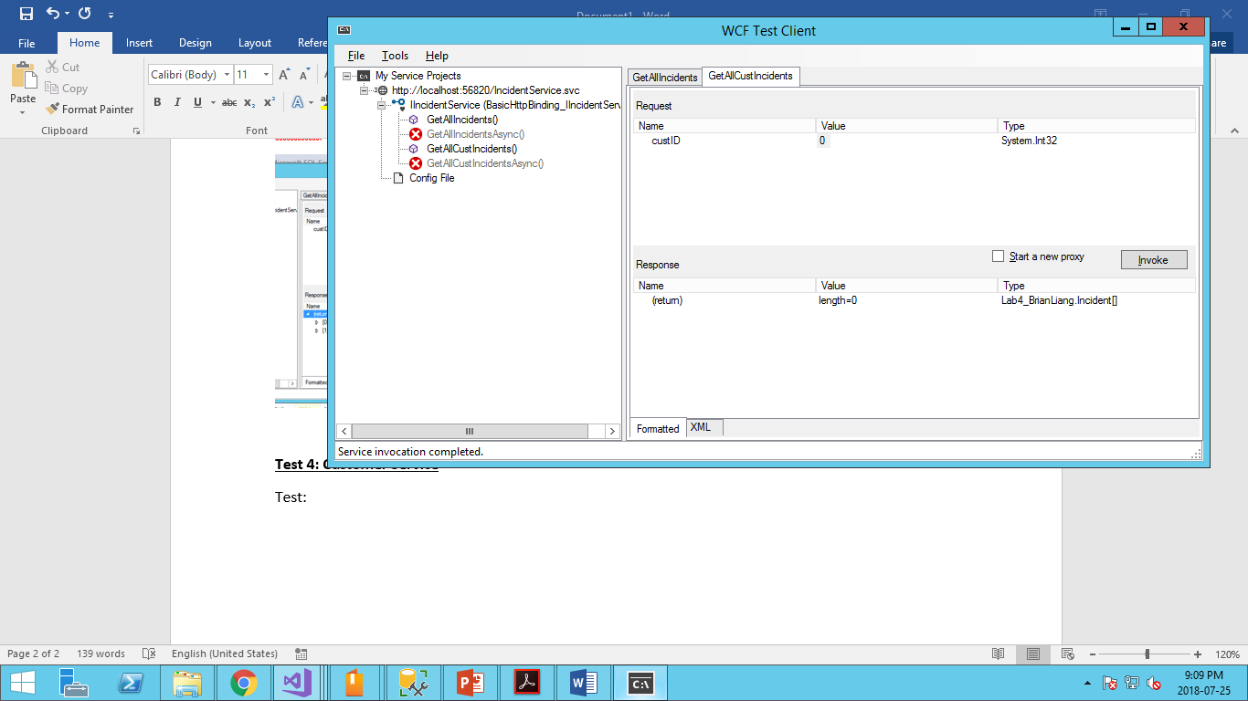

**Test 5: Web Client**

Test: On load

Result: The data grid is being populated based on the customerID in the dropdown list. And for customerID 1008, it is showing the correct incident information. If we check the dropdown list, there is also no repeating customerID. Which is good!

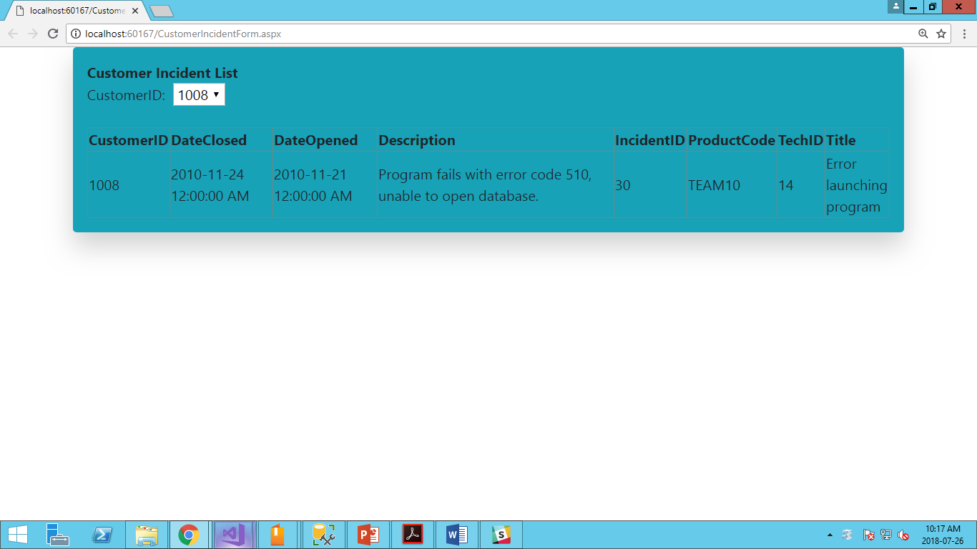

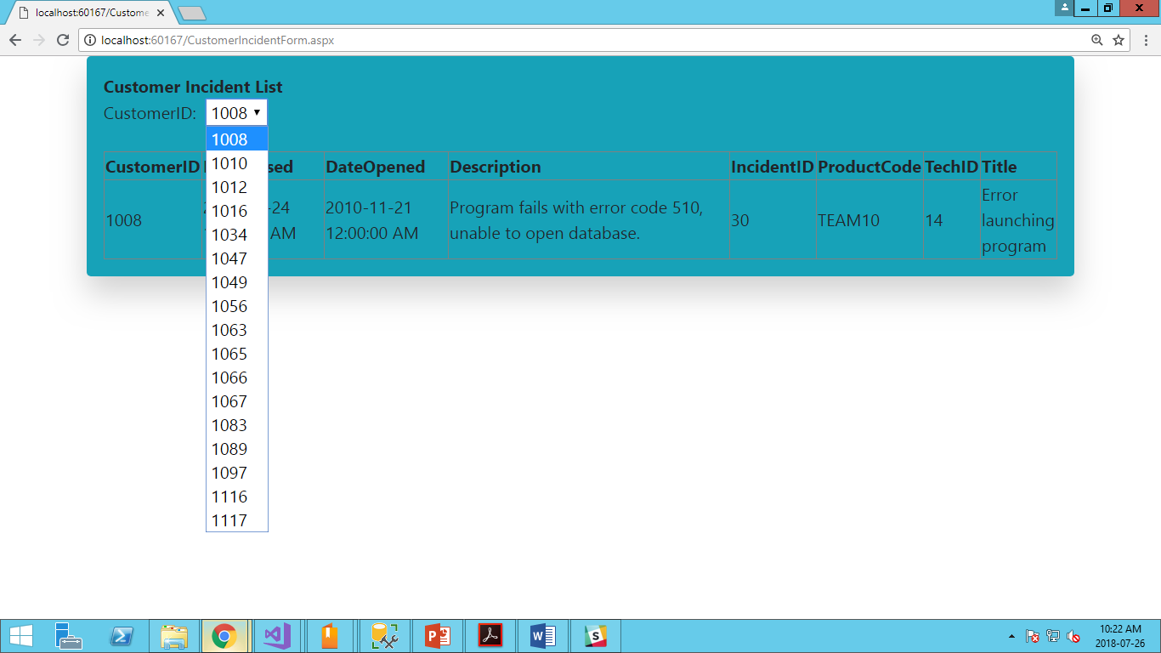

**Test 6: Web Client**

Test: Check a customerID with multiple incidents (CustomerID 1116)

Result: Changing the dropdown to 1116, it loads the incidents and we see both incidents in the data grid.

